Order No:162/2026
Dated: 02-01-2026
Subject: Assignment of Duties and Allocation of Modules for Conduct of Capacity Building Training Programmes under Mission YUVA.
In pursuance of the decisions taken in the meeting held on 02-01-2026 under the chairmanship of the undersigned, and in connection with the conduct of Capacity Building Training Programmes under Mission YUVA, the following officials/faculty members, divided into three groups, are hereby assigned duties and allocated days for conducting different training modules (mentioned in Annexure-A) for the effective implementation of the programme.
Group-wise Allocation of Officials and Duties:
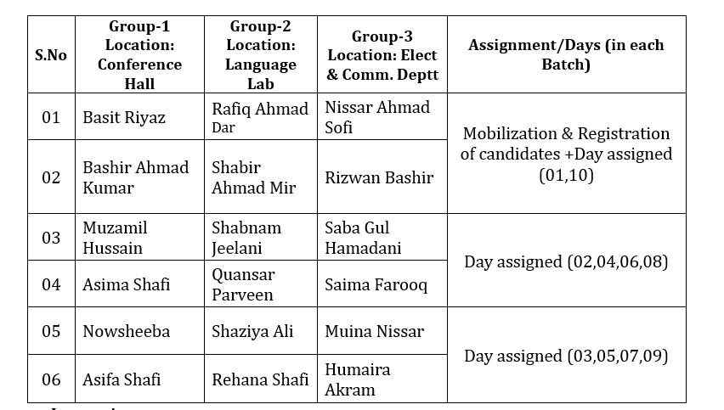

Instructions:
1.The training programme shall be conducted at the location specified against each group.
2.The activity/modules to be conduct on a particular day is mentioned in the Annexure-A with this order.
3.All officials shall work in close and continuous coordination with the Nodal Officers, Mission YUVA.
4.Assigned modules shall be prepared thoroughly and delivered as per prescribed standards.
5.Timelines and schedules shall be finalized and communicated by the Nodal Officers at the commencement of each batch.
All concerned officials shall perform their duties under the direct supervision of the Nodal Officers, Mission YUVA. Any lapse, negligence, or unsatisfactory performance shall invite strict disciplinary action under relevant rules.
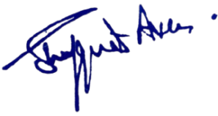

No: KGP/Estt/2025-26/1904
Dated:02-01-2026
Dr. Shafquat Ara
Principal
Kashmir Govt.Polytechnic College Srinagar

